|  |  |  |  |
| --- | --- | --- | --- |
| **Name 1** |  | **ID 1** |  |
| **Name 2** |  | **ID 2** |  |
| **Remarks** |  | **Time** |  |

**Prefix : ___Follow the IP address in the diagram**

You have to implement the given logical topology into a physical topology.

By default all the ports are connected but shutdown. You are required to turn on only the required port for your topology.

**Restriction**

2 persons from the same tutorial group

You must implement the logical topology into the given physical topology. You are not allowed to change the given IP addressing format, rewire, remove or add any additional links.

Each group will be given a topology from the set of 10 topologies (hand drawn) will be given during lecture or tutorial session, a prefix, IPv4 or IPv6 routing.

The physical topology filename looks like the given diagram below.

<http://10.106.36.230/tsn2201/Assignment/Assignment2018Chan.pka>

**Router to Router Connection.**

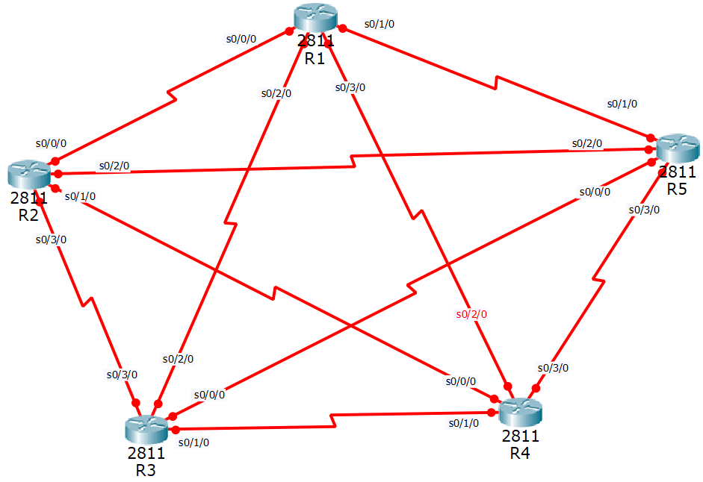

**Router to switch Connection.**

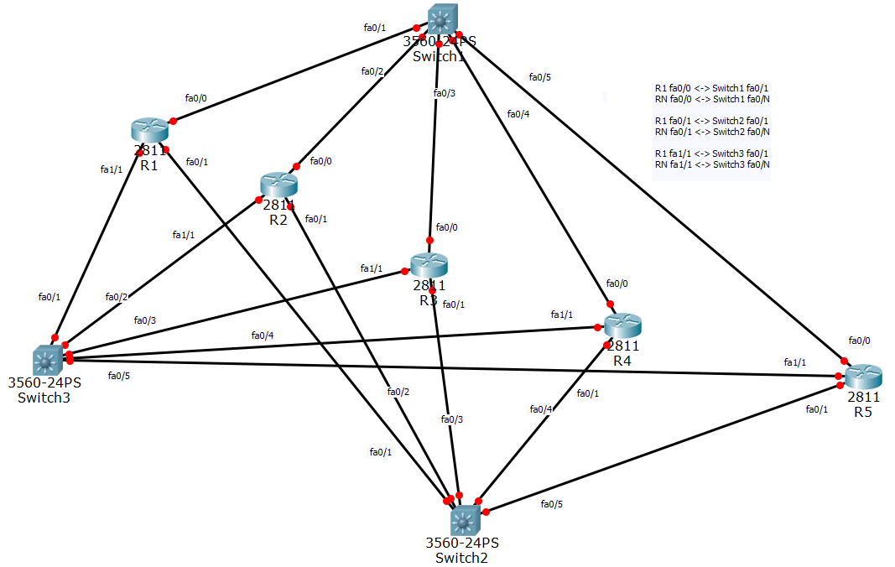

**Switch to switch to PC and Server connection**

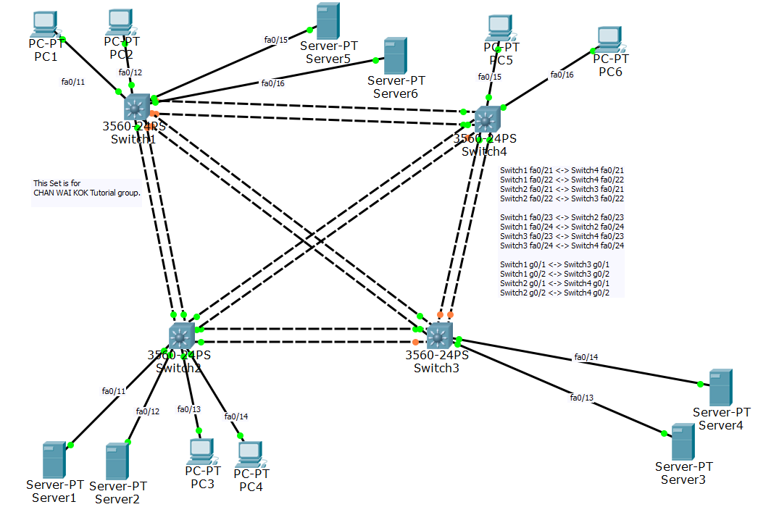

Standard IP addressing.

|  |  |  |
| --- | --- | --- |
| Devices | Last digit of IPv4 Addressing | Last digit of IPv6 addressing |
| R1 | X.X.X.1 | X:X:X:X:X:X:X:1 |
| R2 | X.X.X.2 | X:X:X:X:X:X:X:2 |
| R3 | X.X.X.3 | X:X:X:X:X:X:X:3 |
| R4 | X.X.X.4 | X:X:X:X:X:X:X:4 |
| R5 | X.X.X.5 | X:X:X:X:X:X:X:5 |
| SW1 | X.X.X.6 | X:X:X:X:X:X:X:6 |
| SW2 | X.X.X.7 | X:X:X:X:X:X:X:7 |
| SW3 | X.X.X.8 | X:X:X:X:X:X:X:8 |
| SW4 | X.X.X.9 | X:X:X:X:X:X:X:9 |
| PC1 | X.X.X.11 | X:X:X:X:X:X:X:11 |
| PC2 | X.X.X.12 | X:X:X:X:X:X:X:12 |
| PC3 | X.X.X.13 | X:X:X:X:X:X:X:13 |
| PC4 | X.X.X.14 | X:X:X:X:X:X:X:14 |
| PC5 | X.X.X.15 | X:X:X:X:X:X:X:15 |
| PC6 | X.X.X.16 | X:X:X:X:X:X:X:16 |
| Server1 | X.X.X.21 | X:X:X:X:X:X:X:21 |
| Server2 | X.X.X.22 | X:X:X:X:X:X:X:22 |
| Server3 | X.X.X.23 | X:X:X:X:X:X:X:23 |
| Server4 | X.X.X.24 | X:X:X:X:X:X:X:24 |
| Server5 | X.X.X.25 | X:X:X:X:X:X:X:25 |
| Server6 | X.X.X.26 | X:X:X:X:X:X:X:26 |

**Sample topology and IP addressing for your understanding**

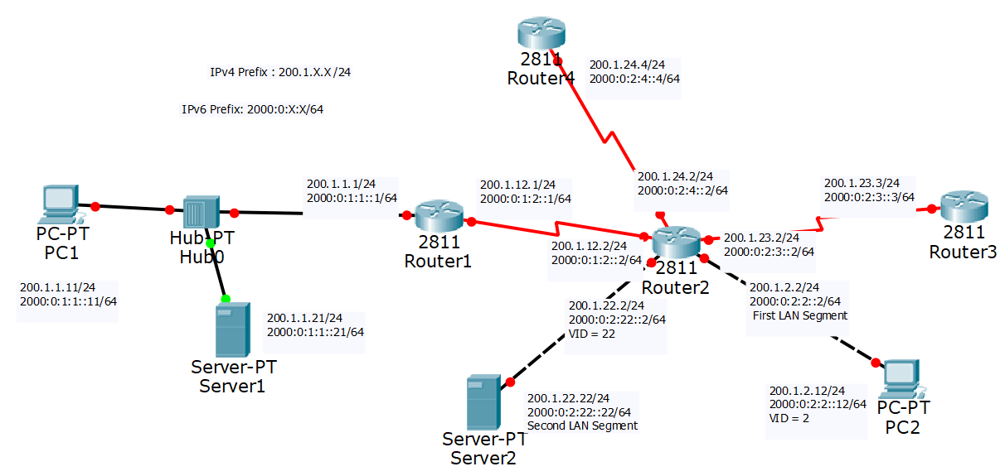

FYI, the hub does not exist in the topology, it is used to illustrate a share network in the diagram only.

**IPv4 Addressing.**

Prefix = _____._______.??.??/24

First LAN IPv4 Add (PC) = ____.____.RtrNo.RtrNo /24 in this case, the VLAN ID :VID is the RtrNo.

Second Lan IPv4 Add (Server) = ____.____.***RtrNoRtrNo****.*RtrNo /24 in this case, the VLAN ID :VID is the ***RtrNo.RtrNo***

IP Add = ____.____.XY.X/24 for RtrX or SwX and Y = _____._____.XY.Y/24, X < Y

where there is a direct connection between RtrX or SwX and RTrY or SwY

**IPv6 Addressing.**

Prefix = _____._______.??.??:/64

First LAN IPv6 Add (PC) = ____.____.RtrNo.RtrNo::RtrNo/64 in this case, the VLAN ID :VID is the RtrNo.

Second LAN IPv6 Add (Server) = ____.____.RtrNo.***RtrNoRtrNo***::RtrNo/64 in this case, the VLAN ID :VID is the ***RtrNoRtrNo***.

IPv6P Add = ____.____.X.Y::X/64 for RtrX or SwX and Y = _____._____.X.Y::Y/64, where X < Y

where there is a direct connection between RtrX or SwX and RTrY or SwY.

Let said the prefix is 2001:0:X:X:/64RtrNoX is directly connected to RtrNoY and X < Y, then the IPv6 Addressing should be

RtrNoX IPv6 address will be 2001:0:RtrNoX:RtrNoY::RtrNoX

RtrNoY IPv6 address will be 2001:0:RtrNoX:RtrNoY::RtrNoY

The IPv6 network prefix will be 2001:0:RtrNoX:RtrNoY::/64

The basic PacketTracer file can be loaded from <http://10.106.36.230/tsn2201/Assignment/>

Your Layer 2 topology is

|  |  |  |
| --- | --- | --- |
|  |  |  |
| Topo 1 | Topo 2 | Topo 3 |

**Layer 2 Topology**

**Spanning Tree.**

Configure the network so that

|  |  |  |  |
| --- | --- | --- | --- |
| No | Primary Root Switch | Secondary Root |  |
| 1 | LSW1 | LSW2 |  |
| 2 | LSW2 | LSW3 |  |
| 3 | LSW3 | LSW4 |  |
| 4 | LSW4 | LSW1 |  |

The Bridge priority of the root switch cannot be zero.

IPv4 /IPv6 Topology. Set No : Sample 1. Actual topology will be given soon via hand drawn.

Prefix : _____________________

Routing Protocol : RIP /Multi area OSPF

|  |
| --- |
|  |

**Grading**

|  |  |  |  |
| --- | --- | --- | --- |
| No | Description | Marks |  |
| 1 | All devices can ping IPv4/IPv6 | 30 |  |
| 2 | The traceroute output reflect the logical IPv4/ipV6 topology | 30 |  |
| 3 | STP is configured properly | 10 |  |
| 4 | DNS  E.g.  Two Domain: @abc.com.my  @xyz.com.my | 10 |  |
| 5 | Web server  I.E. [www.abc.com.my](http://www.abc.com.my)  www.xyz.com.my | 10 |  |
| 6 | Email Server:  I.E. [user1@abc.com.my](mailto:user1@abc.com.my) can send email to user2@xyz.com.my | 10 |  |

**Note: to prevent copying each group will do a different topology, different IPv4 and IPv6 addressing and different DNS Domain Name.**

**Submission**

1. Demo on week 13 and week 14 to your tutor/lecturer in-charge according to the grading table.
2. Submit your final softcopy of your Packet Tracer files.
3. Submit a Hardcopy and softcopy of the complete logical topology in 3 page using ppt slides. Icon files will be provided at http://10.106.36.230/tsn2201/Assignment/
4. IPv4/IPv6 topology with complete interface number and IPv4 /IPv6 addressing
5. Layer 2 topology